**Digital Nurture 4.0 Java FSE**

**Week 7 ReactJS - HOL**

**Mandatory Exercise (HandsOn 13)**

**Exercise 13:**

Create a React App named “bloggerapp” in with 3 components.

1.Book Detail

2.Blog Details

3.Course Details

Implement this with as many ways possible of Conditional Rendering.

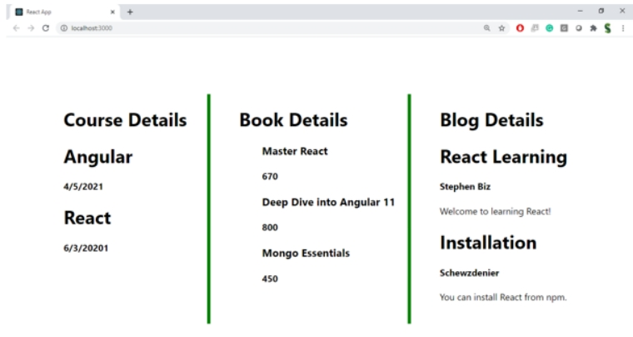

**Answer:**

**App.js:**

import React, { useState } from "react";

import "./App.css";

function App() {

  const [showBook, setShowBook] = useState(true);

  const [showBlog, setShowBlog] = useState(true);

  const [showCourse, setShowCourse] = useState(true);

const books = [

    { id: 1, bname: "Master React", price: "670" },

    { id: 2, bname: "Deep Dive into Angular 11", price: "800" },

    { id: 3, bname: "Mongo Essentials", price: "450" },

  ];

const courses = [

    { name: "Angular", date: "4/5/2021" },

    { name: "React", date: "6/3/2021" },

  ];

const bookdet = showBook && (

    <ul>

      {books.map((book) => (

        <li key={book.id}>

          <h3>{book.bname}</h3>

          <p>₹{book.price}</p>

        </li>

      ))}

    </ul>

  );

const content = showBlog ? (

    <ul>

      <li>

        <h3>React Learning by Stephen Biz</h3>

        <p>Welcome to learning React!</p>

      </li>

      <li>

        <h3>Installation by Schwezdenier</h3>

        <p>You can install React from npm.</p>

      </li>

    </ul>

  ) : (

    <p>Blog is hidden</p>

  );

const coursedet = (() => {

    if (!showCourse) return null;

    return (

      <ul>

        {courses.map((course, index) => (

          <li key={index}>

            <h3>{course.name}</h3>

            <p>{course.date}</p>

          </li>

        ))}

      </ul>

    );

  })();

return (

    <div className="container">

      <div className="column">

        <h1>Course Details</h1>

        <button onClick={() => setShowCourse(!showCourse)}>

          {showCourse ? "Hide Courses" : "Show Courses"}

        </button>

        {coursedet}

      </div>

<div className="column">

        <h1>Book Details</h1>

        <button onClick={() => setShowBook(!showBook)}>

          {showBook ? "Hide Books" : "Show Books"}

        </button>

        {bookdet}

      </div>

<div className="column">

        <h1>Blog Details</h1>

        <button onClick={() => setShowBlog(!showBlog)}>

          {showBlog ? "Hide Blog" : "Show Blog"}

        </button>

        {content}

      </div>

    </div>

  );

}

export default App;

**App.css:**

body {

  font-family: sans-serif;

  margin: 0;

  padding: 20px;

  background-color: #f9f9f9;

}

.container {

  display: flex;

  justify-content: space-between;

  border-left: 3px solid green;

  border-right: 3px solid green;

  background-color: white;

}

.column {

  flex: 1;

  padding: 20px;

  border-right: 3px solid green;

}

.column:last-child {

  border-right: none;

}

h1 {

  font-size: 20px;

  margin-bottom: 10px;

  text-align: center;

  text-decoration: underline;

}

button {

  margin-bottom: 10px;

  display: block;

  margin-left: auto;

  margin-right: auto;

}

h3 {

  margin: 5px 0;

  font-weight: bold;

}

h4, p, li {

  margin: 5px 0;

}

**Book.js:**

import React from "react";

const books = [

  { id: 1, bname: "Master React", price: "₹670" },

  { id: 2, bname: "Angular 11", price: "₹800" },

  { id: 3, bname: "Mongo Essentials", price: "₹450" },

];

function Books() {

  return (

    <div className="st2">

      <h1>Book Details</h1>

      <ul>

        {books.map((book) => (

          <div key={book.id}>

            <h3>{book.bname}</h3>

            <h4>{book.price}</h4>

          </div>

        ))}

      </ul>

    </div>

  );

}

export default Books;

**Blog.js:**

import React from "react";

function Blog() {

  return (

    <div className="v1">

      <h1>Blog Details</h1>

      <h3>React Learning</h3>

      <p>Welcome to learning React!</p>

      <h3>Installation</h3>

      <p>You can install React from npm.</p>

    </div>

  );

}export default Blog;

**Couses.js:**

import React from "react";

const courses = [

  { name: "Angular", date: "4/5/2021" },

  { name: "React", date: "6/3/2021" },

];

function Courses() {

  return (

    <div className="mystyle1">

      <h1>Course Details</h1>

      <ul>

        {courses.map((course, index) => (

          <li key={index}>

            {course.name} - {course.date}

          </li>

        ))}

      </ul>

    </div>

  );

}

export default Courses;

**Output in next page**

**Output:**



